05 – 08 – 2026
Netshell commands
1.interface show interface
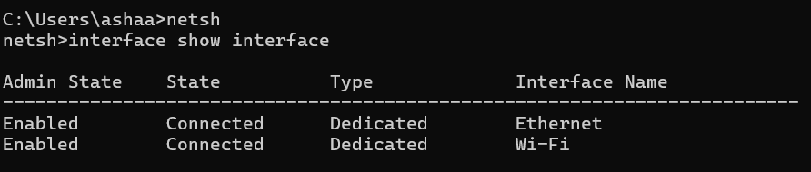

2. interface ipv4 show interfaces
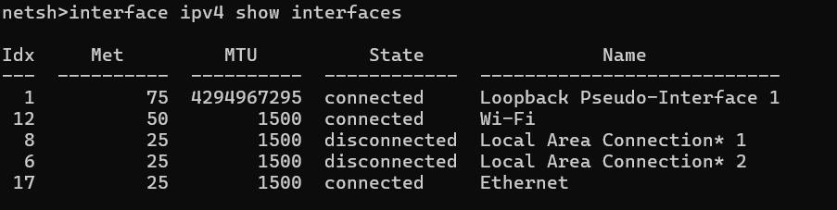

3. interface ipv6 show interfaces
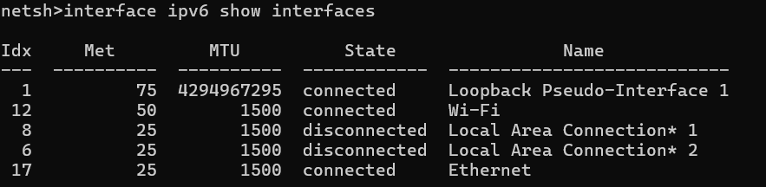

4. interface ip show config
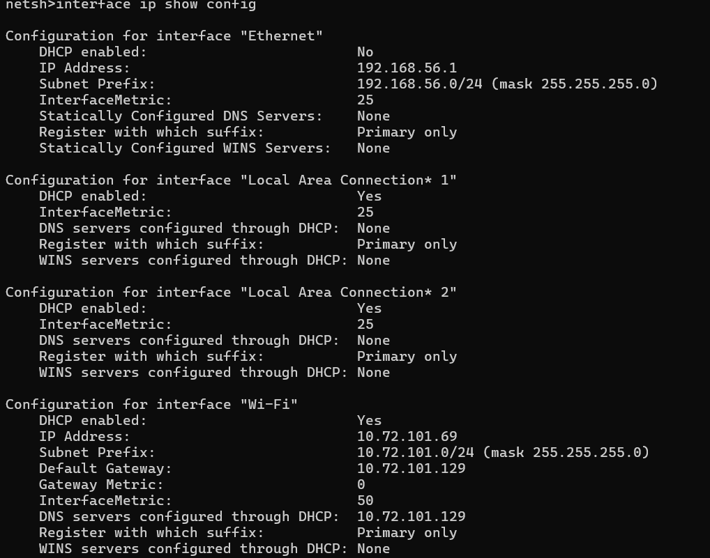
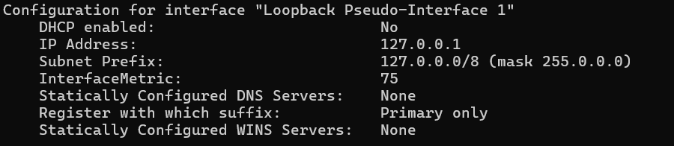

5. interface ipv4 show config

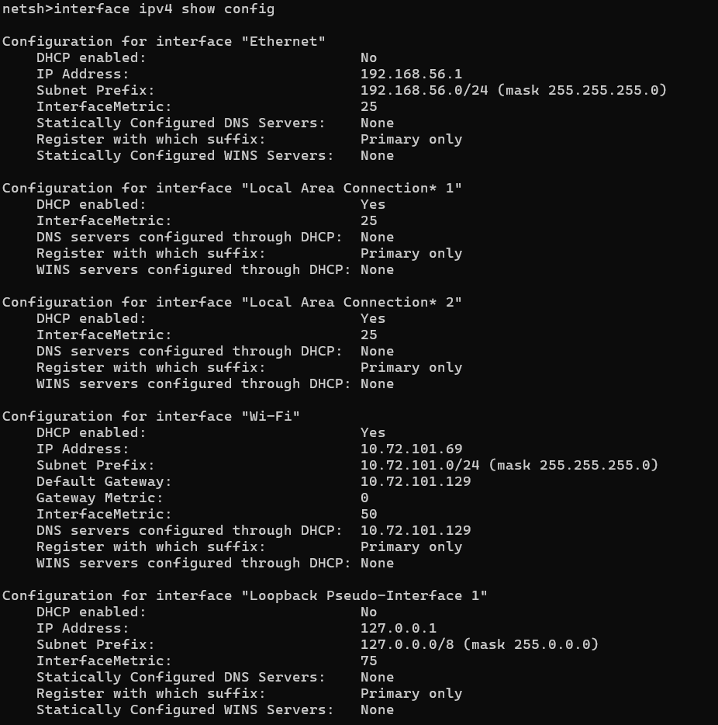

6. interface ipv6 show addresses
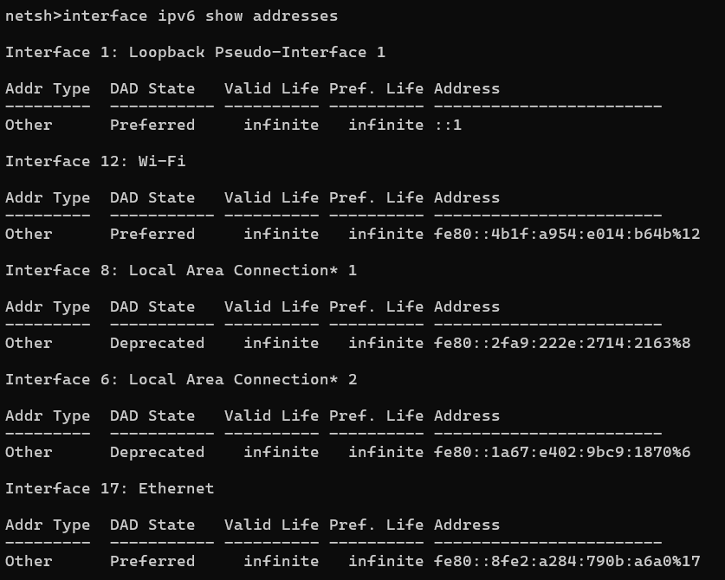

7. wlan show profiles
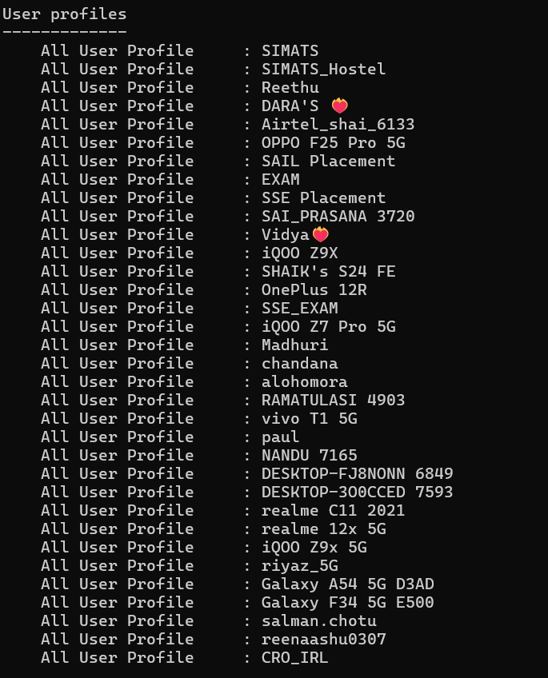
8. wlan show profile name="riyaz_5G" key=clear
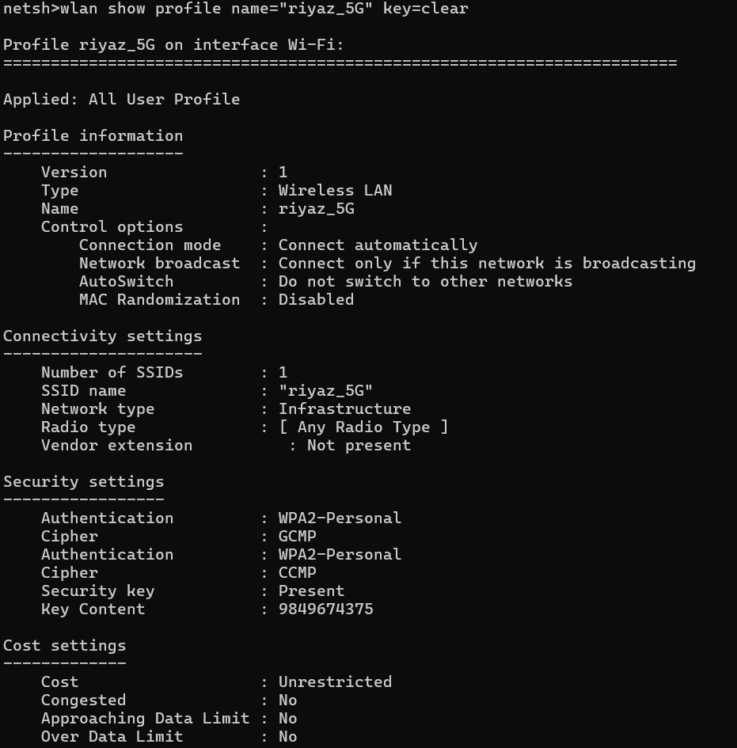

9. Get-NetNeighbor -AddressFamily IPv4
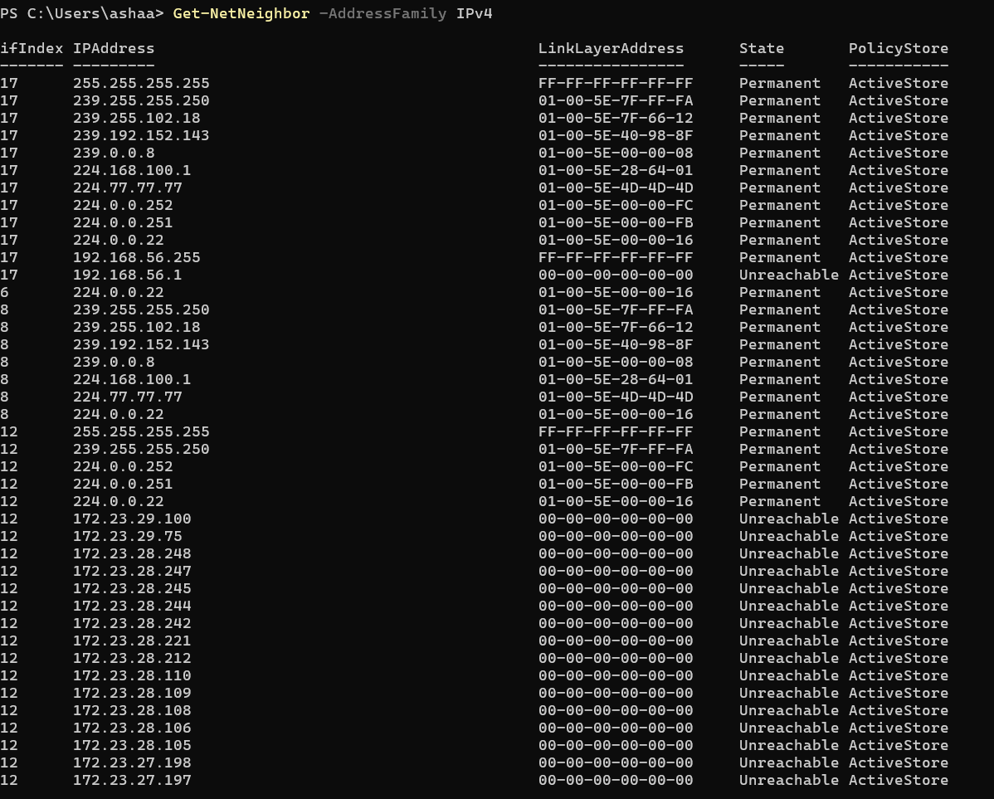
10. Get-NetNeighbor -AddressFamily IPv6
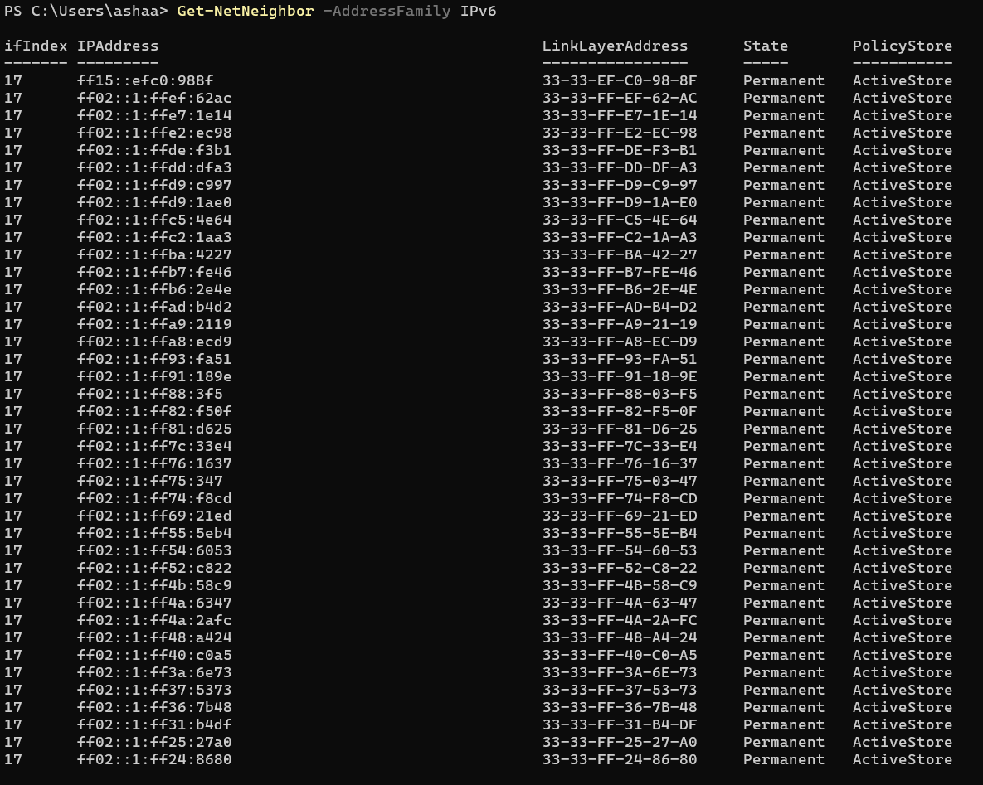
11. wlan show drivers
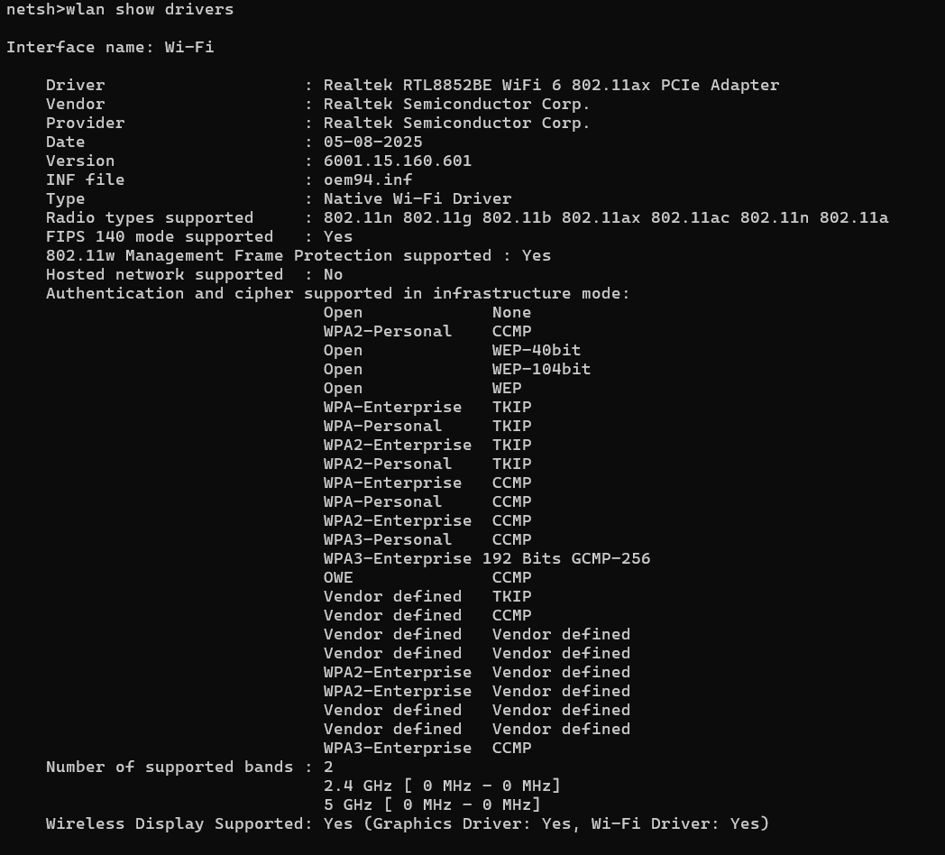
12. wlan show networks mode=bssid

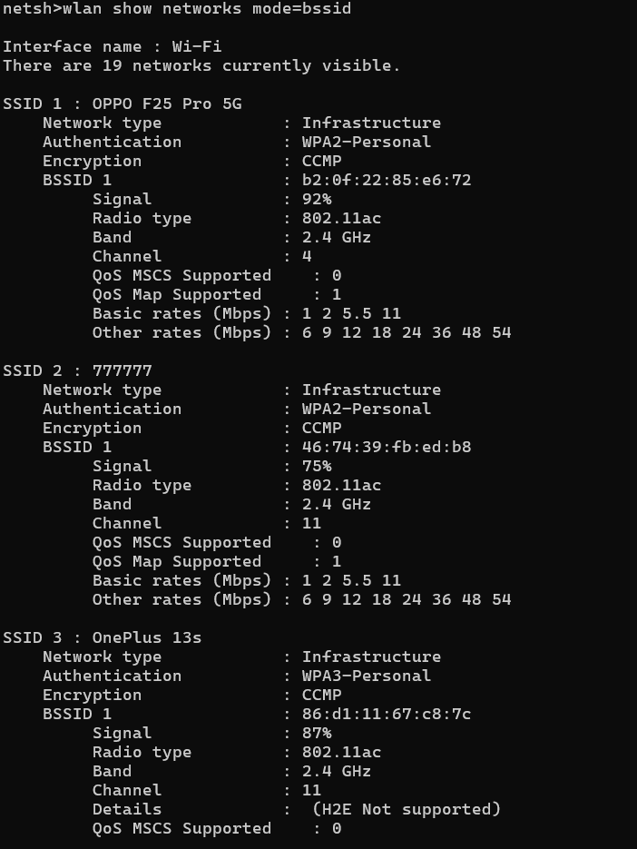
13. advfirewall show currentprofile
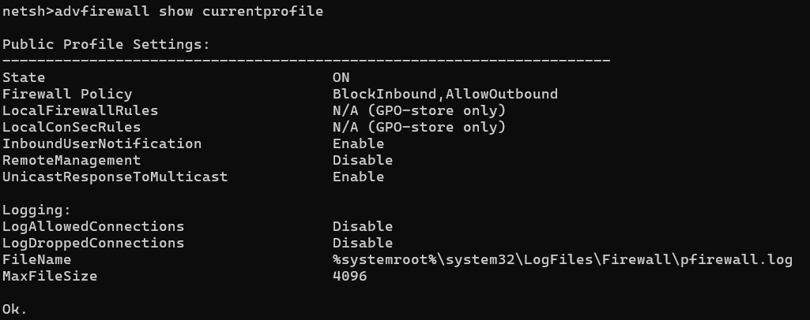

14. advfirewall show allprofiles
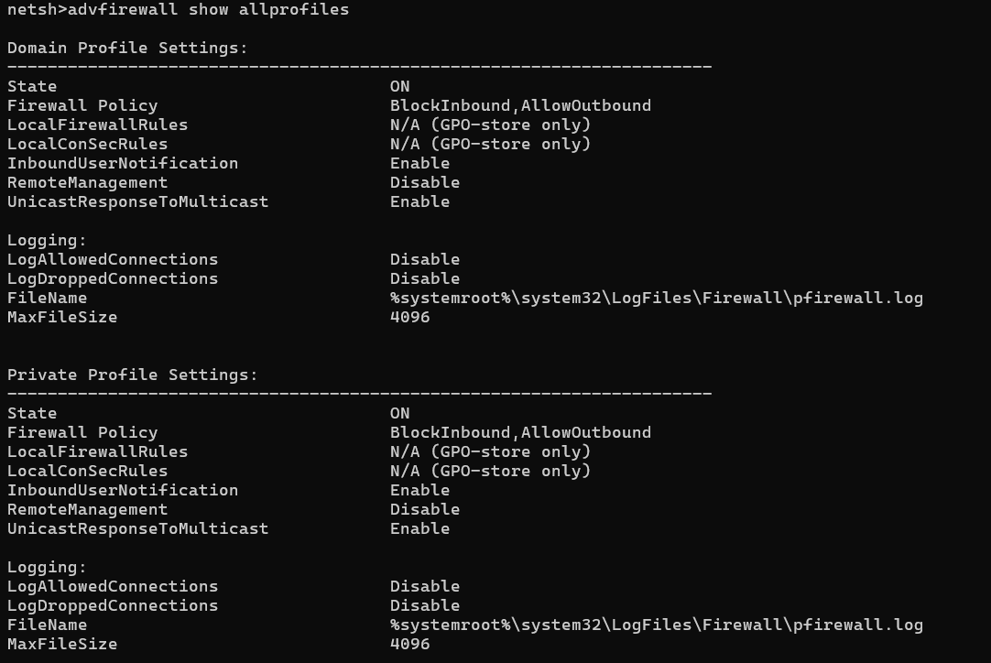

15. winhttp show proxy
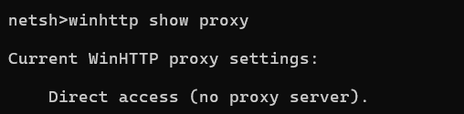
16. Get-PnpDevice -Class Bluetooth
